Information Technology Institute

.Net Full Stack Developer

**Examination System**

# Supervisor:

# Eng. Mrihan Mohamed

## Presented by:

## Ali Zakarya Kamal Thabet

## Islam Gamal Mohamed Hussin

## Hassan Khalaf Hassan Tawfik

### **DATABASE DESIGN (ERD)**

Examination system ERD includes entities such as Student, Instructor, Intake, department, students, questions, courses, grades, and their relationships to each other.

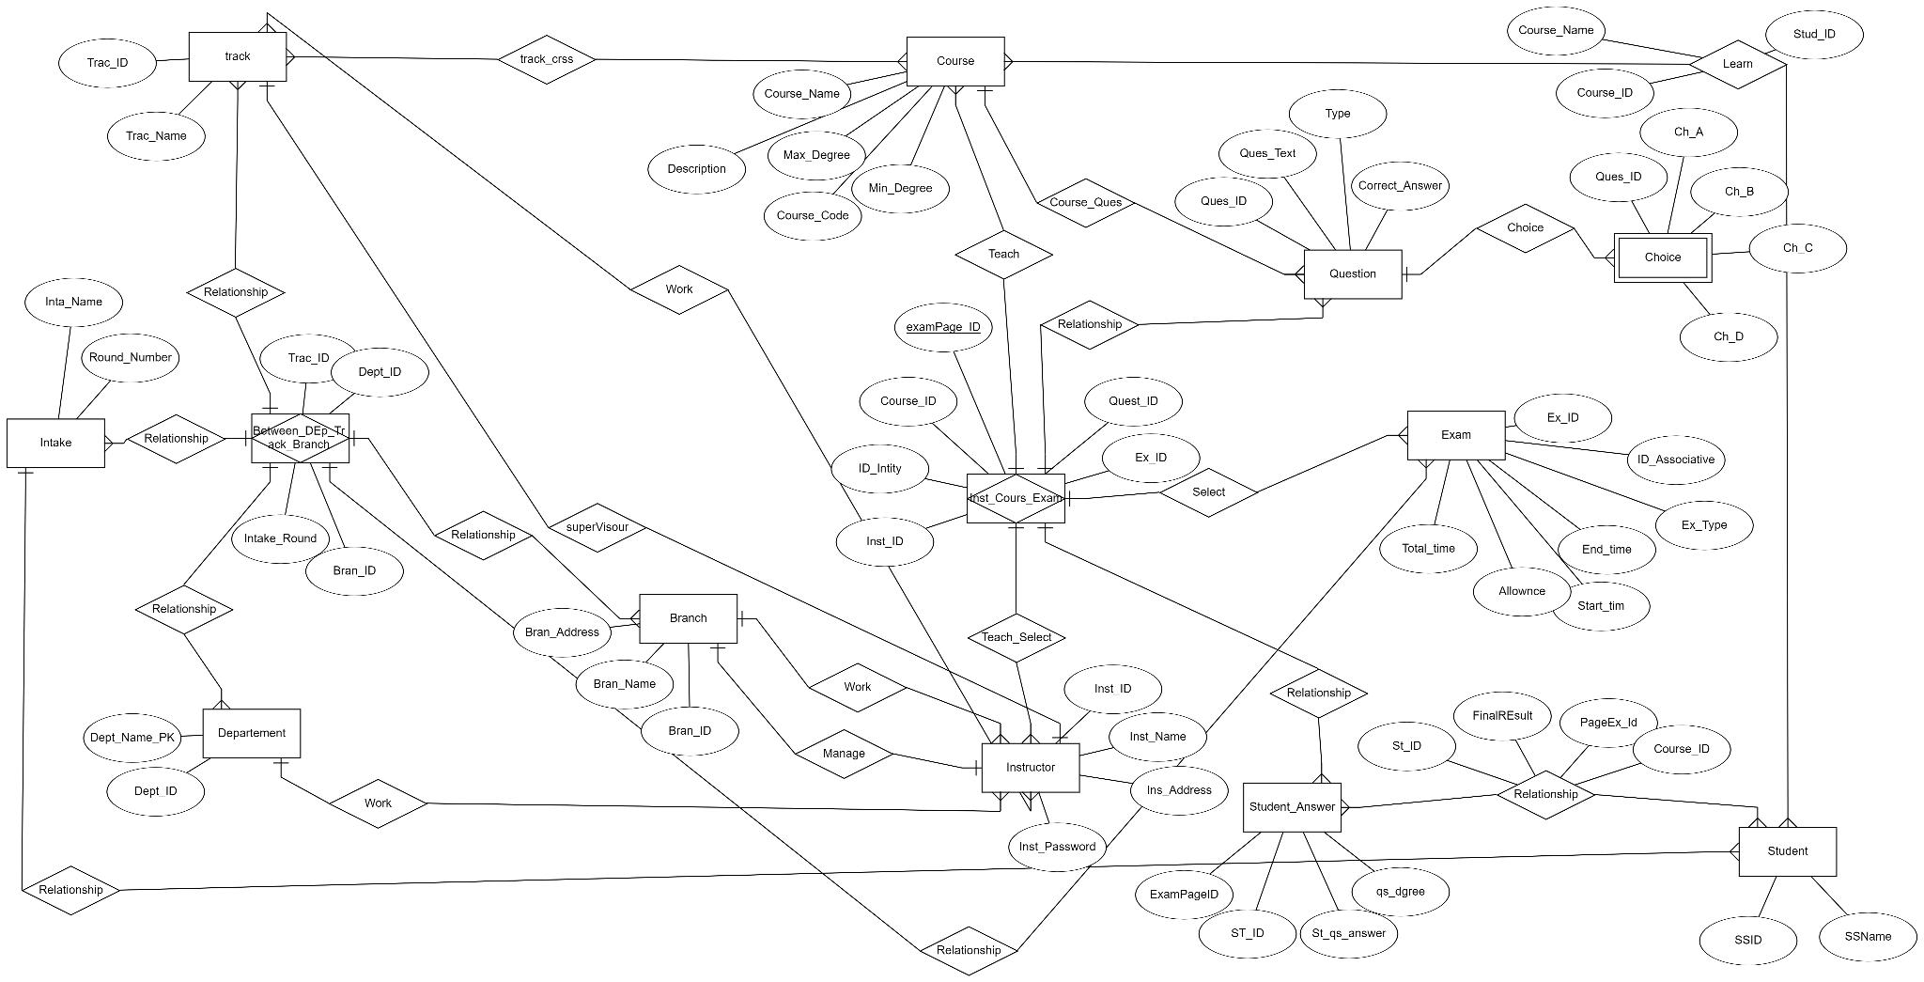

## **DATABASE DESIGN (MAPPING)**

Mapping in the examination system refers to creating a correspondence or association between different entities or attributes in the system needed to implement in the SQL Server Management Studio.

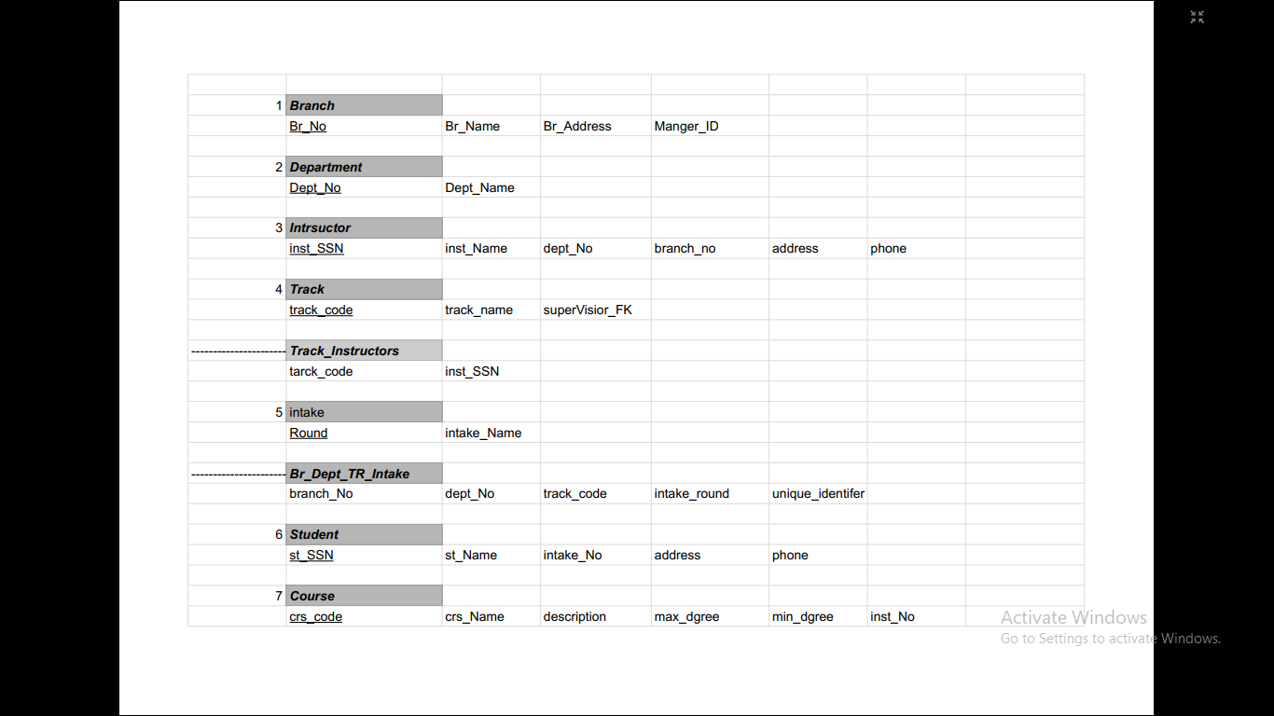

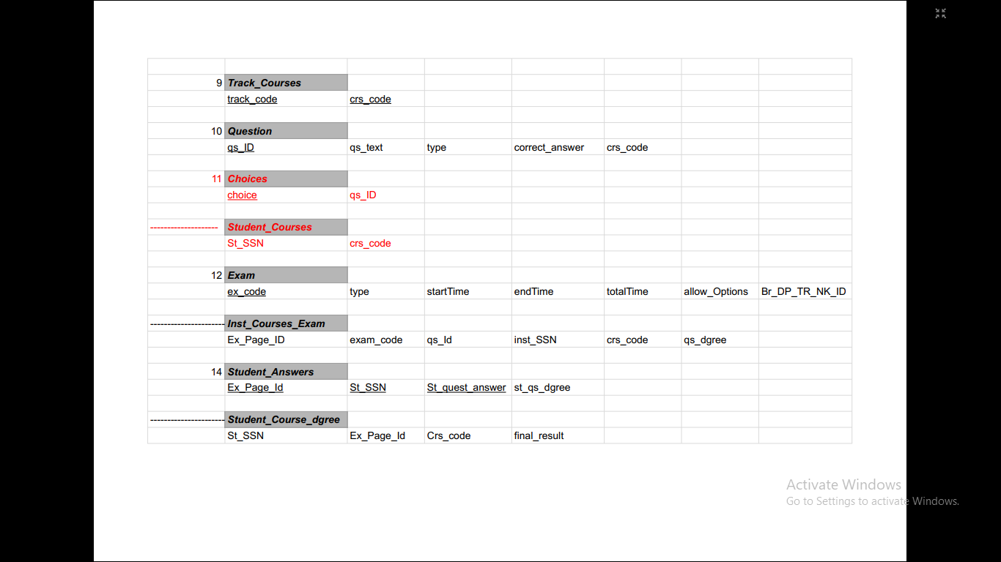

## **Mapping Tables**

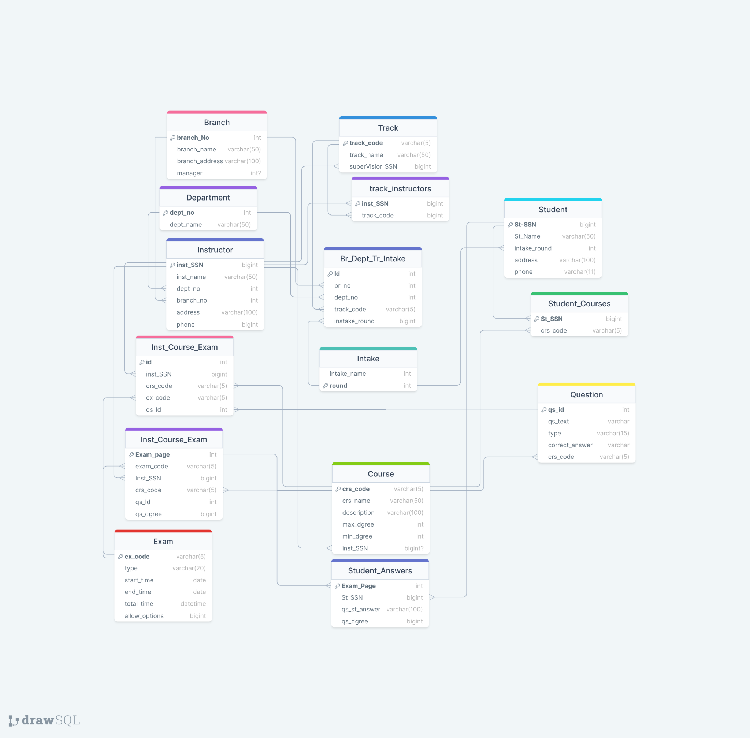

## **IMPLEMENTATION**

Creating a database for an examination system typically involves defining tables to store information about the Topic, Course, Instructor, Student, Department, and Exam Once we defined the table schema, we populated the tables with data. We used the Bulk Insert command. This command allows for efficiently inserting large amounts of data into tables from a data file. The data file can be CSV in our system.

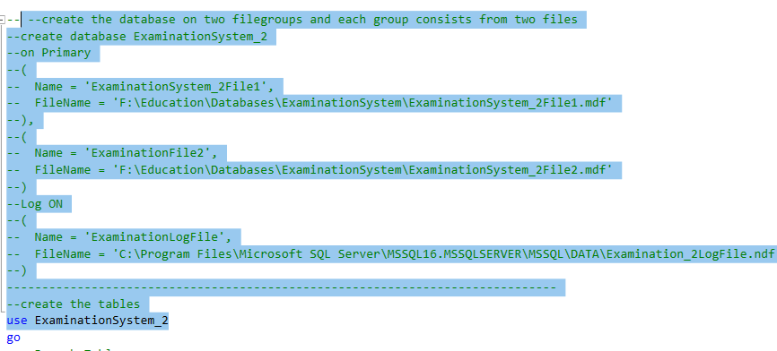

The file of the creation database is named:

Create_Database_ExaminationSystem.sql

It contains the creation of all tables and constraints

# **Data Snapshots**

### **Training Manager Functionality :**

The folder creation of all training manager functions is called:

Training Manager Functionality

1-Branch

--- Show all branches

SELECT * FROM TrainingManagerFunctionality.Select_Branches()

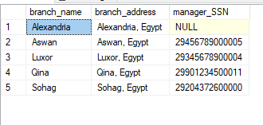

--Add new branch

--takes three parameters : the branch name{the primary key} , the –branch address,

------and the manager SSN {which is referenced from Instructor –table}

-------the manager must exist on a database

exec TrainingManagerFunctionality.Add_Branch @branch_name='Assuit',@branch_address='Assuit, Egypt',

@manager_SSN='29901234500011'

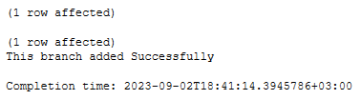

---add new Branch with new manager

--- takes parameters :

----------------> branch name

----------------> branch address

----------------> new manager ssn { must consist from 14 number }

----------------> Manager full name

----------------> manager address

----------------> manager phone number { must consists from 11 number}

TrainingManagerFunctionality.addNewBranchWithNewManager 'Minya',' Minia, Egypt', '29009876500003',

'Ahmed Tawfik',' Alexandria, Egypt', '01098765431'

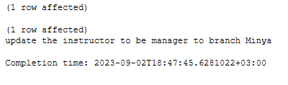

There are more functions belonging to the branch :

TrainingManagerFunctionality.Delete_Branch

TrainingManagerFunctionality.Update_Branch

2-Department

--add department

--> takes one parameter: department name

TrainingManagerFunctionality.add_Department 'Security'

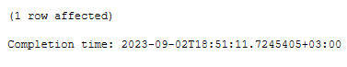

There are more functions belonging to the department :

TrainingManagerFunctionality.Update_Department

TrainingManagerFunctionality.Delete_Department

3-Instructor

----->> Show Instructors :

TrainingManagerFunctionality.showAllInstructors

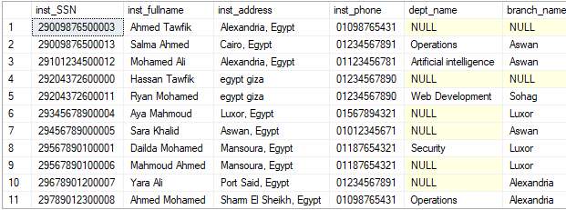

--->> Add instructor

---> takes parameters :

------------> instructor ssn {primary key} must be 14 number

------------> full name

------------> address

-------------> phone number and must be 11 number

------------> department name { foreign references department table}

------------> branch name { foreign key references branch table}

TrainingManagerFunctionality.addNewInstructor '295678901000012',' Dailda Mohamed',' Mansoura, Egypt', '01187654321',' Security', 'Luxor'

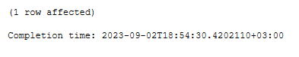

There are more functions belonging to the instructor :

TrainingManagerFunctionality.checkInstructor

TrainingManagerFunctionality.deleteInstructor

TrainingManagerFunctionality.updateInstructor

4-Track

--> add track

-- takes parameters :

------------>> track code { the primary key of table}

------------>> tarck name

----------->> supervisor ssn { references to instructor ssn}

TrainingManagerFunctionality.Add_Track 'SE',' Software Engineering','29789012300008'

There are more functions belonging to the track :

TrainingManagerFunctionality.Delete_Track

TrainingManagerFunctionality.Update_Track

TrainingManagerFunctionality.addCourseToTrack

TrainingManagerFunctionality.addInstructorToTrack

5-Course

---> Show all courses

TrainingManagerFunctionality.Display_Courses;

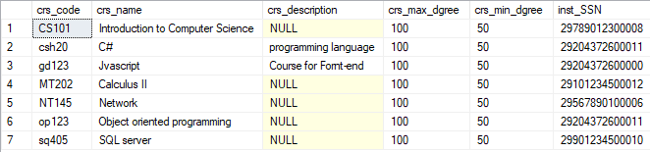

There are more functions belonging to the track :

TrainingManagerFunctionality.Add_Course

TrainingManagerFunctionality.Update_Course

TrainingManagerFunctionality.Delete_Course

6-Intake

--- show all inatkes

TrainingManagerFunctionality.showAllIntakes

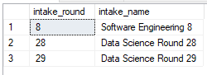

-- show all branches that the intake on it

-- takes intake round number

TrainingManagerFunctionality.showIntakeBranches 29



There are more functions belonging to the Intake :

TrainingManagerFunctionality.addIntake

TrainingManagerFunctionality.IntakeBranch

TrainingManagerFunctionality.checkIntake

TrainingManagerFunctionality.deleteIntakeFromBranches

7-Student

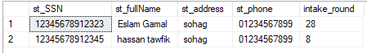

[TrainingManagerFunctionality].[Add_Student]

[TrainingManagerFunctionality].[Delete_Student]

[TrainingManagerFunctionality].[Update_Student]

### 

### **Instructor Functionality :**

1-Question

--Show all questions belong to the course

-- takes course code as a parameter

InstructorFunctionality.showAllQuestionChoices ‘csh20’

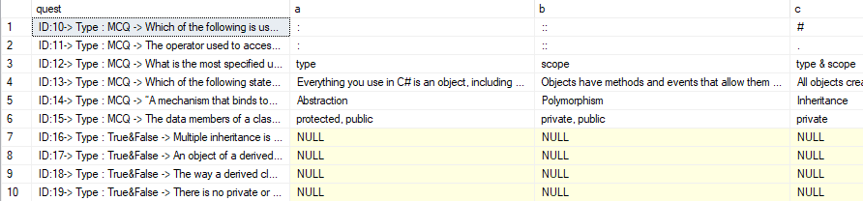

There are more functions belonging to the Questions :

InstructorFunctionality.addQuestion

InstructorFunctionality.updateQuestionChoice

InstructorFunctionality.updateQuestionOrCorrectAnswer

InstructorFunctionality.deleteQuestion